MediKiosk AI: Building a Smarter Patient Case-Taking Experience with AI Memory
I Built a Patient Case-Taking Agent That Remembers
A patient shouldn't have to explain the same medical history from scratch every time they return.
That was the problem we wanted to explore with MediKiosk AI: a patient-facing case-taking assistant that can collect information through voice or touch, organize medical history, process documents, identify predefined red flags, and prepare a structured summary for a physician. The part that made the system particularly interesting was giving it persistent memory with Hindsight.
Instead of treating every consultation as an isolated conversation, MediKiosk can retain relevant information from previous interactions and recall it when that information becomes useful again.
The Problem: Clinical History Is Often Scattered
Medical history is one of the most important parts of a consultation, but collecting it can be repetitive and time-consuming.
Patients may have previous prescriptions, laboratory reports, discharge summaries, or information from earlier consultations. They may also forget details that were discussed during previous visits.
In a conventional workflow, this information can be spread across paper records, documents, conversations, or manually entered systems.
We wanted to approach the problem from a different direction:
What if the patient could provide their information naturally, while an AI system organized the information into a structured clinical history?
MediKiosk AI was designed around that idea.
The system is not intended to diagnose patients. Instead, it focuses on collecting, organizing, and presenting information so that the physician can review it efficiently.
How MediKiosk AI Works
The overall workflow is straightforward:
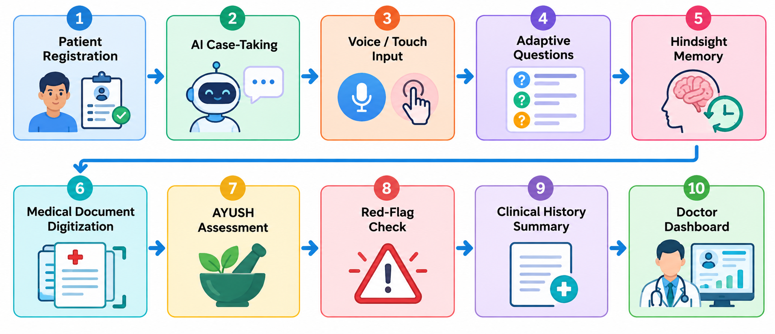
A patient can enter information through text or voice. The system processes the complaint, asks follow-up questions, retrieves relevant previous information, processes uploaded medical documents, performs predefined red-flag checks, and finally presents the collected information through a physician dashboard.
The interesting part isn't any individual feature.
Why Memory Matters
A normal conversational system primarily works with the information available in the current conversation.
For patient case-taking, that can be limiting.
Consider a simple example.
During a previous consultation, a patient named Priya reports:
Patient: Priya
Complaint: Fever and cough
Duration: 3 days
Several days later, Priya returns and says:
"I have fever again."
Without persistent memory, the system starts from the current conversation.
It might ask:
"How long have you had fever?"
With relevant memory, the system can retrieve information from the previous consultation and ask a more contextual question:
"You previously reported cough along with fever. Are you experiencing cough this time?"
That difference is small from an implementation perspective, but significant from an interaction perspective.
The system isn't simply remembering information for the sake of storing it. The memory is useful because it changes what the agent asks next.
That became the central technical idea behind our implementation
Using Hindsight as the Memory Layer
We integrated Hindsight agent memory as the persistent memory layer of MediKiosk.
The basic workflow is:
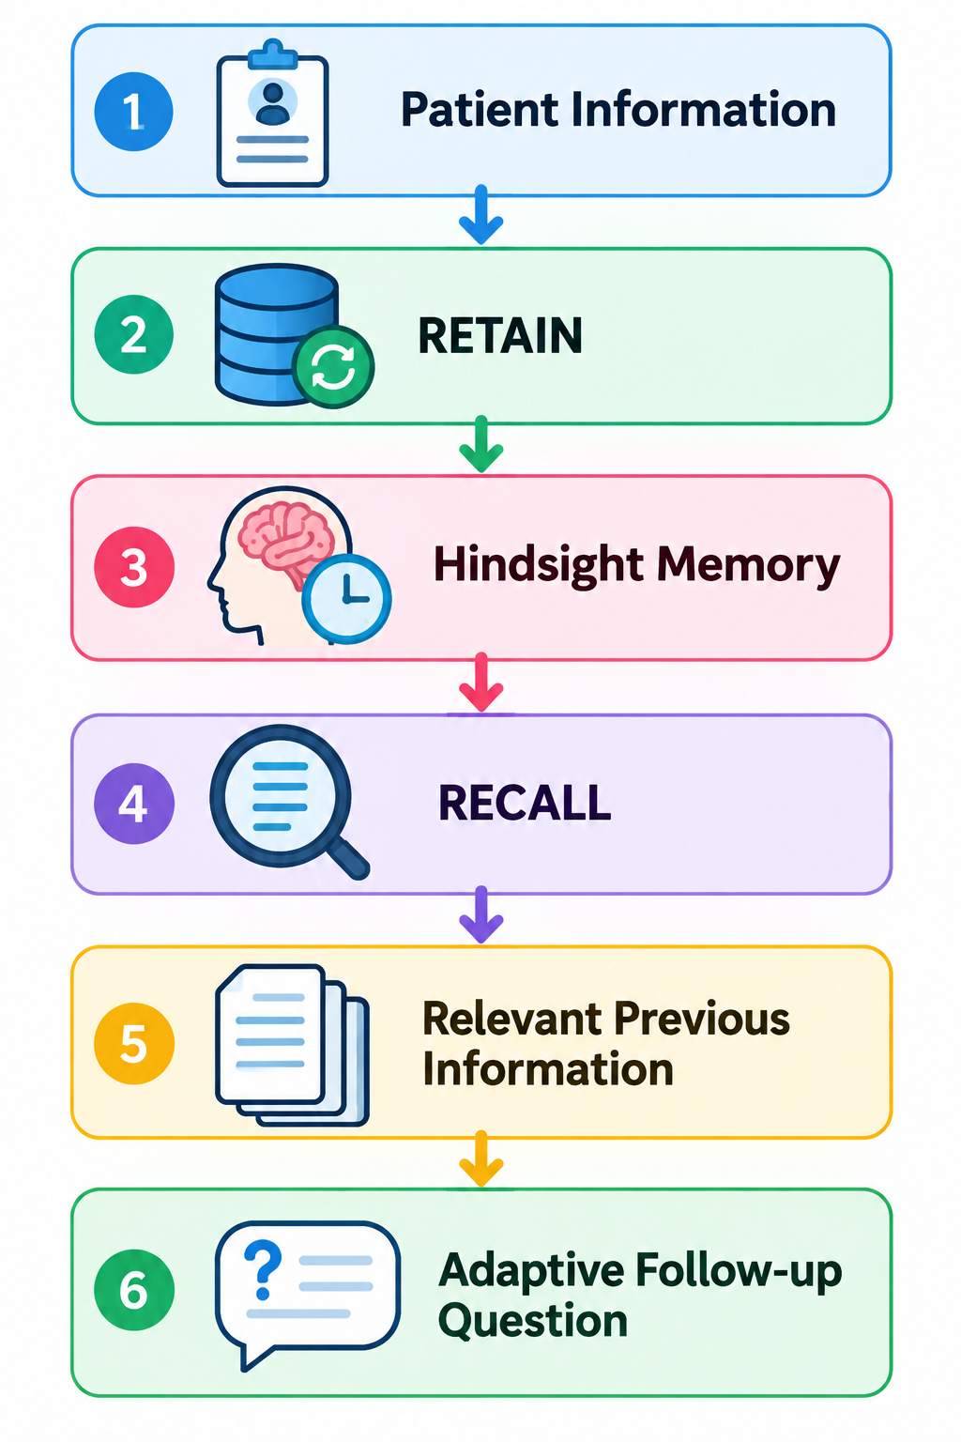

A simplified version of the implementation looks like this:
from hindsight_client import Hindsight

client = Hindsight(
base_url="https://api.hindsight.vectorize.io",
api_key="YOUR_API_KEY"
)

client.retain(
bank_id="medikiosk",
content="Patient Priya reported fever and cough for 3 days."
)

result = client.recall(
bank_id="medikiosk",
query="Previous medical history of Priya related to fever"
)
The important distinction is between retaining information and recalling information.
After a consultation, relevant information can be retained. During a future consultation, the application can query the memory layer for information relevant to the patient's current complaint.
We used asynchronous Hindsight methods in the application environment so that memory operations can work with the rest of the application without unnecessarily blocking the workflow.
For more details, the Hindsight GitHub repository and Hindsight documentation provide the underlying memory concepts and integration details.
The Interesting Part: Memory Changes the Questions
Adding a memory database by itself isn't particularly interesting.
The important question is:
What does the agent actually do with the retrieved memory?
For MediKiosk, the answer is adaptive follow-up questions.
Our agent.py logic uses retrieved memories together with the current complaint.
A simplified version looks like this:
def generate_follow_up(memories, complaint):

if not memories:
return "How long have you been experiencing this problem?"

previous_text = " ".join(memories).lower()

if "cough" in previous_text and "fever" in complaint.lower():
return (
"You previously reported cough along with fever. "
"Are you experiencing cough this time?"
)

if "fever" in previous_text:
return (
"You previously reported fever. "
"When did the current fever start?"
)

return "Can you tell me more about your current symptoms?"
This is intentionally simple.
The goal wasn't to build a system that pretends to understand everything about medicine. The goal was to demonstrate a clear memory-driven behavior:
previous information → relevant recall → better follow-up question.
That separation also made the system easier to reason about.
Voice and Touch Instead of Forms Alone
MediKiosk is designed to support both touch/text interaction and voice input.
A patient can type a complaint:
"I have fever and cough."
Or provide it through voice:
Patient
↓
Speech Recognition
↓
Text Complaint
↓
AI Case-Taking Agent
The prototype uses speech recognition to convert spoken information into text before processing it.
This matters because typing a complete medical history isn't necessarily convenient for every patient. A conversational interface gives the patient another way to provide information while allowing the application to transform that information into a structured format.
Bringing Existing Medical Documents Into the Workflow
Another problem is that patients often already have medical information somewhere else.
They may have prescriptions, reports, or discharge summaries stored as documents.
MediKiosk allows users to upload supported documents such as PDF and DOCX files.
The workflow is:
Physical / Existing Medical Document
↓
Upload
↓
Text Extraction
↓
Structured Clinical History
The extracted text can become part of the patient's clinical history summary.
The prototype uses tools such as PyPDF and python-docx for document processing.
This means the system doesn't have to depend entirely on information typed during the current interaction.
Adding AYUSH-Specific Assessment
Because our solution is designed with the AYUSH healthcare context in mind, we also included fields for Dashavidha Pariksha parameters.
The prototype collects information including:
- Prakriti
- Vikriti
- Sara
- Samhanana
- Pramana
- Satmya
- Sattva
- Ahara Shakti
- Vyayama Shakti
- Vaya
These values become part of the structured clinical history and can be displayed alongside the patient's other information in the physician dashboard.
The intention is not to replace clinical assessment. It is to organize the information collected from the patient into a form that can be reviewed by the healthcare professional.
Red-Flag Identification
We also added predefined red-flag identification.
The system checks collected information for terms associated with potentially urgent symptoms, including:
- Chest pain
- Difficulty breathing
- Severe bleeding
- Loss of consciousness
- Seizure
- Severe abdominal pain
If a predefined red-flag term is detected, the system displays a priority alert:
🚨 Priority Alert
This is deliberately positioned as an information alert rather than a diagnosis or emergency decision.
The purpose is to make potentially important information visible to medical staff so it can receive appropriate clinical attention
The Doctor Dashboard
After the case-taking process, the collected information is brought together in the physician dashboard.
The dashboard combines:

Patient Details
+
Chief Complaint
+
Previous History
+
AYUSH Assessment
+
Medical Documents
+
Triage Alerts
+
Clinical History Summary
Instead of requiring the physician to look through multiple separate sources, the information is presented through one interface.
The generated summary is still intended for clinical review. The physician remains responsible for interpreting the information and making clinical decisions.
Before and After Persistent Memory
The clearest way we found to understand the value of Hindsight was to compare the same type of interaction.

Without relevant memory
Patient:
"I have fever."

System:
"How long have you had fever?"

Patient:
"Three days."

System:
"Do you have any other symptoms?"
The system is working only with the current conversation.
With Hindsight memory
Previous consultation:
Fever + cough for 3 days
New consultation:
Patient:
"I have fever again."
The memory layer retrieves the relevant previous information.
The system can then ask:
"You previously reported cough along with fever.
Are you experiencing cough this time?"
The second interaction is more contextual because the system has access to relevant information from the previous encounter.
This before-and-after behavior was the main reason persistent memory became an important part of our architecture.
Keeping the Architecture Modular
The application uses Python and Streamlit, with different responsibilities separated into individual modules.

Component | Technology
Frontend | Streamlit
Programming | Python
AI Memory | Hindsight
Voice Input | SpeechRecognition
Document Processing | PyPDF, python-docx
Clinical Summary | Python-based generation
Triage | Rule-based red-flag detection
Data Flow | Python modules + Streamlit session state
The project is organized into modules such as:
app.py
memory.py
agent.py
summary.py
triage.py
dashboard.py
integration.py
Each module has a relatively focused responsibility.
memory.py handles communication with Hindsight.
agent.py handles memory retrieval and adaptive questioning.
summary.py prepares the clinical history.
triage.py handles predefined red-flag detection.
dashboard.py presents the information to physicians.
integration.py represents the HIS and ABDM integration layer.
This separation became useful because we could reason about each part independently rather than putting the entire workflow into one large application file.
What I Learned
The biggest lesson from building MediKiosk was that adding AI does not automatically make a system useful.
The more important question is:
Can the system remember something useful and use it at the right time?
A few lessons stood out.
1. Memory is useful only when it changes behavior
Simply storing previous conversations doesn't create a better user experience.
The retrieved information needs to affect what the system does next.
For MediKiosk, that means using previous information to make follow-up questions more contextual.
2. Keep responsibilities separate
Memory, questioning, document processing, triage, summaries, and dashboards don't need to live in one piece of code.
Separating them made the project easier to understand and extend.
3. Healthcare systems need clear boundaries
The system should help organize clinical information without presenting itself as a replacement for the physician.
That boundary influenced how we designed the summary and red-flag functionality.
4. A small behavior can demonstrate a bigger architectural idea
Our memory example is simple: remember that a patient previously reported cough and ask about it when fever appears again.
But that simple interaction demonstrates the larger idea of persistent agent memory much more clearly than simply saying that the system has a memory database.
What's Next
MediKiosk is currently a prototype, but the architecture provides several directions for future development.
Potential improvements include:
- More natural conversational case-taking
- Better multilingual voice interaction
- OCR for scanned medical documents and images
- More advanced document understanding
- Secure authentication and role-based access
- Real HIS integration
- ABDM-compatible interoperability
- More sophisticated memory retrieval
- Better personalization of follow-up questions
- Additional AYUSH assessment workflows
- Improved accessibility for elderly and differently abled patients
The long-term goal is to create a secure, interoperable, patient-friendly system that helps organize relevant information before the patient enters the consultation room.
Conclusion
MediKiosk AI started with a simple observation: patient history shouldn't have to start from zero every time.
By combining voice and touch interaction, persistent Hindsight memory, medical document digitization, AYUSH assessment, predefined red-flag identification, and a physician dashboard, we built a workflow that focuses on one specific problem: making patient information collection more structured and contextual.
The most important part isn't that the system can remember.
It's that the memory can be used when it matters.
A previous consultation becomes useful information for the next one. A previous symptom can influence the next question. A document can become part of the structured history. And the final information can be presented to the physician in one place.
That is the direction we want to continue exploring: AI that doesn't just respond to the current conversation, but can use relevant past context to make the next interaction more useful.
MediKiosk is our step toward making patient case-taking more structured, contextual, and efficient—while keeping the physician at the center of clinical decision-making.

